Victoria’s Major Events
Victoria plays host to some of Australia and the world’s biggest
and best sporting, cultural, food & wine, entertainment and business events.

Australian Tennis Open
Occurring over two weeks in January each year, the Australian Tennis Open is the first Grand Slam tennis tournament of the year, and is the only Grand Slam event hosted in the Asia-Pacific region. Over 250 elite tennis players from all around the world come to compete at the Melbourne Park precinct.

Melbourne Food & Wine Festival
Melbourne Food & Wine Festival highlights why Melbourne is a world-class gastronomic destination, attracting visitors from across Australia and around the globe. Taking place over almost three weeks, the event is hosted across Melbourne, from famous dining spots to unexpected venues, rooftop bars to hidden cellars, each year the Festival goes beyond eating and drinking to create memory-making experiences.

Melbourne International Flower and Garden Show
The Melbourne International Flower and Garden Show is the biggest annual flower show in the Southern Hemisphere. Hosted at the World Heritage Listed Royal Exhibition Building and Carlton Gardens, the show will see the creativity and passion of Australia's top floral and landscape designers delivered in stunning displays, accompanied by exhibitions of garden, floral and outdoor products.

Australian Formula 1 Grand Prix
In March, the world’s fastest and most innovative racing cars speed into Melbourne as part of the Australian Formula 1 Grand Prix. The motor race takes place on a custom street circuit through Melbourne’s Albert Park and Lake Precinct, with over 300,000 people attending to witness four days of breathtaking action.
Australian Automotive Week
Australian Automotive Week is Australia's annual premier showcase for the automotive industry. Held in March to coincide with the Australian Formula 1 Grand Prix, the week is designed to drive business engagement and be a part of a series of events and activities that highlight Australia’s state-of-the-art automotive and manufacturing capabilities.

Melbourne Fashion Festival
The Melbourne Fashion Festival is an annual celebration of fashion, beauty, business and creative endeavour for everyone to enjoy. The Festival presents the most stylish week-long entertainment on offer including world-class runway shows featuring Australia’s established and emerging designers, state-of-the-art production, beauty workshops, industry seminars, forums, live entertainment and much more.

Melbourne International Comedy Festival
The Melbourne International Comedy Festival is one of the three largest comedy festivals in the world, alongside Edinburgh Festival Fringe and Montreal's Just for Laughs Festival. The festival takes over Melbourne each autumn with an enormous program
of stand-up comedy, cabaret, theatre, street performance, film, television, radio and visual arts.

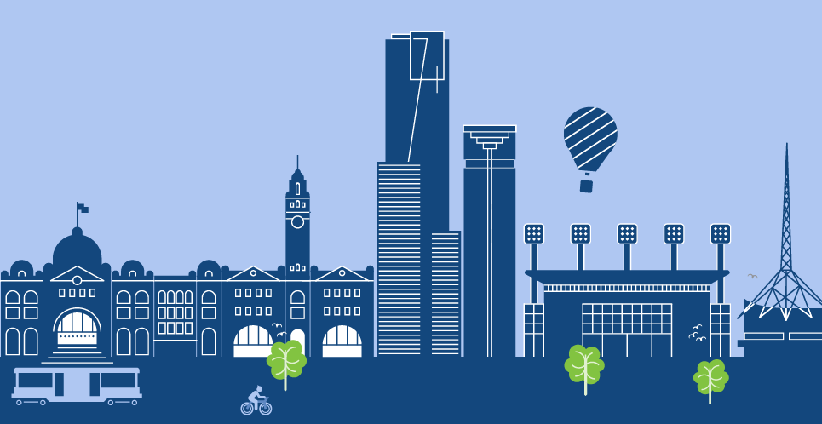
Australian International Airshow
Every two years, Avalon Airport, Geelong, Victoria
(45 minutes south-west of Melbourne) hosts the Australian International Airshow and Aerospace & Defence Exposition. The show features a large number of vintage, classic and experimental aircraft and high flying barnstormers and precision stunt performers. The accompanying expo provides opportunities for business investors to network and engage with the aviation industries of Victoria and
the Asia-Pacific region.

Rip Curl Pro
Each year, the world’s best male and female surfers put on their wetsuits and dive into the cool waters of Australia’s home of surfing: Bells Beach. Situated
on the Great Ocean Road (2 hours southwest of Melbourne), the beach will host the Rip Curl Pro Melbourne, an annual event on the ASP Surfing
World Tour.

Melbourne International Jazz Festival
The Melbourne International Jazz Festival is an annual, world-class jazz festival first held in 1998. The Festival takes place in concert halls, arts venues, jazz clubs and throughout the streets of Melbourne as the city comes alive with the spirit of jazz.

Pax Australia
Spawned from the largest consumer games event in North America, PAX Australia is a festival celebrating games culture, it connects the world's leading game publishers with their most avid fans, while providing an inclusive community environment. Melbourne
will host international guests, speakers, musicians
and developers will join local game industry representatives to showcase games and
community events in Australia.

AFL Grand Final
Australian Rules Football is like no other game in
the world, and it is a unique reminder that Melbourne is the sporting capital of Australia. The Australian Football League (AFL) Grand Final takes place in
late September or early October each year and is regarded as the most significant sporting event in Australia and sees over 100,000 fill the classic Melbourne Cricket Ground for the game.

MotoGP Motorcycle Grand Prix
Phillip Island (3 hours southeast of Melbourne) is home to one of the fastest motorcycle racing tracks
in the world, and each October, it hosts the Australian Motorcycle Grand Prix. The event will see the world’s most fearless riders converge on Melbourne for a weekend of high-speed and intensity action.

EQUITANA Melbourne
Equitana in Australia is the most anticipated annual equine event of its kind in the Southern Hemisphere attracting over 50,000 visitors per event. Taking place at the Melbourne showgrounds, Equitana is four days of everything equine featuring horses, Olympic gold medallists, world renowned educators, an elite equine competition program and over 300 exhibitors making up the largest equine shopping spree in Australia.

Boxing Day Test Match
– Melbourne Cricket Ground
Each year, the famous Melbourne Cricket Ground hosts the Boxing Day Test Match, which sees the Australian Cricket Team play a touring national team from countries including England, India and South Africa. This highlight of the Australian summer calendar is one of the most popular sporting events
in the country, with over 200,000 attending the match that can last up to five days.

